
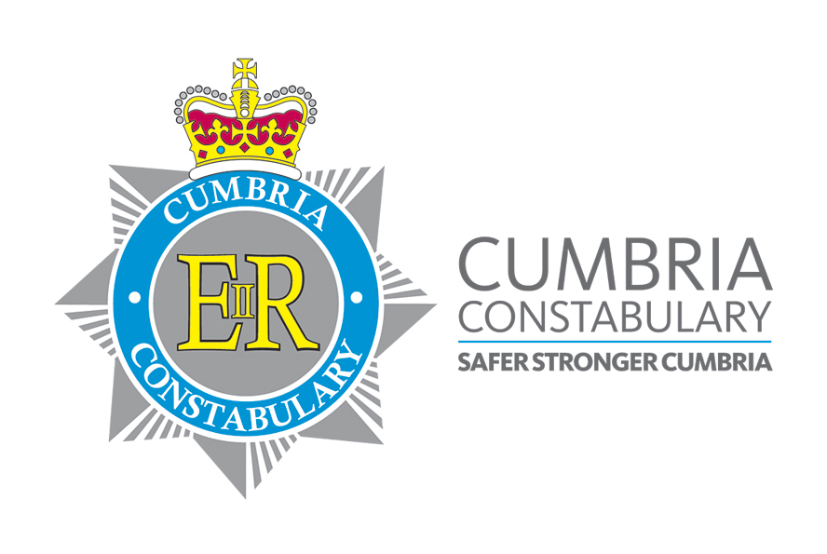

FORCE INTELLIGENCE BUREAU
CARLETON HALL
PENRITH
CUMBRIA
CA10 2AU
E-mail : fib@cumbria.pnn.police.uk
Tel No: 01768 213792
Fax No: 01768 217442

FORCE INTELLIGENCE BULLETIN

REF NO: 2013-113

INFORMATION SOUGHT
In March 2013 the victim places two London Mint coins on eBay for sale, providing a mobile number as a point of contact.

On 6th September 2013 the victim receives a call from a male by the name of peter on Tel number 07935803344. Who asked if he can buy the coins?
The victim has accumulated 59 coins in silver and gold issued by London Mint to the value of £32,000 pounds.

The suspect known as “Peter” arranges the sum of thirty two thousand pounds to be credited into the victim’s bank account.

The suspects enters a NatWest branch in Bury on the 13th September 2013 and submits a fraudulent cheque in the company name Repack services limited. The cheque was submitted and the sum was showing in the victims account.

The victim made arrangement to meet the buyer at Southwaite services, Carlisle M6 southbound, on 15th September at 2pm.
The suspect sent a “courier” by the name of Dave who was described as follows: white male in his 50’s and described as looking like a weasel to exchange the coins.

On this occasion the suspect Peter was texting the victim on Tel number 07516993689.

The exchange took place and the victim left.

On the 18th September 2013 the victim checked his bank account to find the £32,000 pounds had been debited from his account.
The bank informed him that the cheque had not been honoured by the issuing bank as it was a forgery.

Below shows photographs of the coins taken by the Suspect.
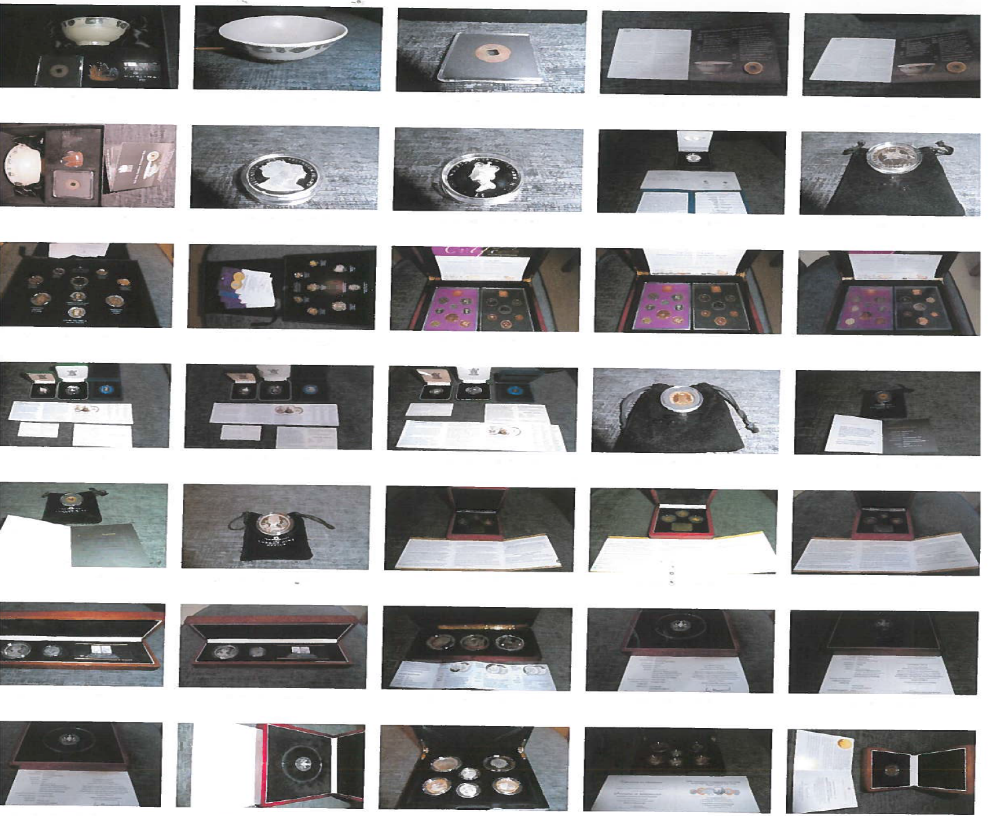
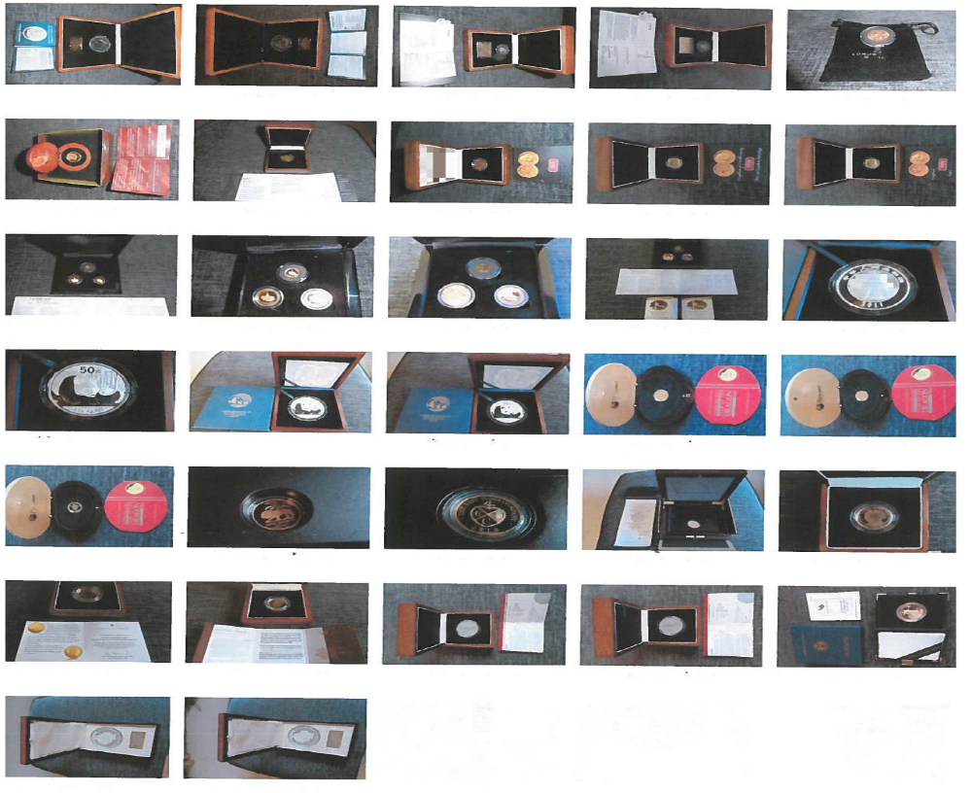

If anyone has any further information or any similar crimes -please contact DC 1345 Vicky HUGHES Tel No: 01228558287
OR EMAIL Vicky.hughes@cumbria.pnn.police.uk

T/Chief Constable
Bernard Lawson

